Wimmera PCP [Enter Name of Document]
[Enter date]
[Enter Revision Date if required]
Liveability Data
Environment
Northern Grampians Shire
2022

ENVIRONMENT
This refers to the physical surrounding of the community. The built and natural environments interact closely and are highly influenced by climate, land use, natural resources, policy and geography.

Food & Water Security
Food
In 2017, 12.4% of residents from Northern Grampians Shire reported that they had run out of food in the previous 12 months and could not afford to buy more - Vic 6.2%
In 2020, 80.0% of residents of Northern Grampians Shire rated their access to fresh fruit and vegetables as ‘good’ - Regional Vic 80.9% Vic 82.7%
In 2020, 14.9% of residents from Northern Grampians Shire rated the ‘lack of affordable food/groceries at local shops’ as a problem - Regional Vic 11.3% Vic 10.0%
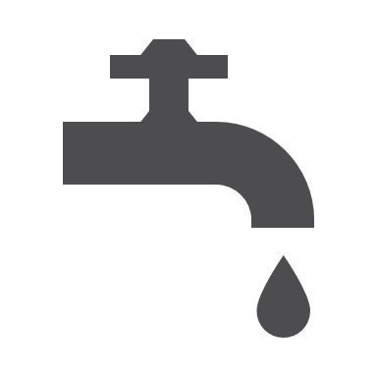
Water
In December 2021 the water storage level for the Grampians Headlands Storage was 40.7% Melbourne water storage 90% (30/12/21)

Built Environment
Building approvals
In the year ending 30 June 2020 there were 21 building approvals for dwellings (including private sector houses and private sector dwellings) in Northern Grampians Shire.
- This represented a decrease of 8 permits from 2019

Solar installations
In 2019 there were 132 small-scale solar panel installations in Northern Grampians Shire, this is an increase of 45 since 2015 - Regional Vic 19,782 Vic 61,741
In 2019 there were 8 solar water heater installations in Northern Grampians Shire - Regional Vic 6,958 Vic 25,249

Roads
In 2020, 47.7% of residents in Northern Grampians Shire rated the quality of local roads as ‘good’ - Regional Vic 48.1% Vic 66.0%
Natural Environment
In the last 30 years (ending 2019) in the Wimmera:
- Annual rainfall has decreased 9%
- Dry years have occurred 12 times and wet years have occurred five times
- There have been more frosts and they have been occurring later
- There have been more hot days, with more consecutive days above 40°C
Climate
At the Stawell Aerodrome:
- The annual mean number of days ≥ 35°C is 14.7 Melbourne Regional Office 10.0
- The annual mean numbers of days ≥ 40°C is 2.5 Melbourne Regional Office 1.3
- The annual mean rainfall is 472.5 mm Melbourne Regional Office 648.3 mm
- The mean daily solar exposure is 16.6 MJ/m² Melbourne Regional Office 15.1 MJ/m²
At St Arnaud:
- The annual mean number of days ≥ 35°C is 15.4 Melbourne Regional Office 10.0
- The annual mean numbers of days ≥ 40°C is 1.7 Melbourne Regional Office 1.3
- The annual mean rainfall is 498.5 mm Melbourne Regional Office 648.3 mm
- The mean daily solar exposure is 17.1 MJ/m² Melbourne Regional Office 15.1 MJ/m²

Protected land area
In 2020, there were 4 National Parks in Northern Grampians Shire Regional Vic 101 Vic 102
- 14.7% of land in was National Park - Regional Vic 13.7% Vic 13.5%
- All other areas of protected land was 3.5% - Regional Vic 4.2% Vic 4.1%

